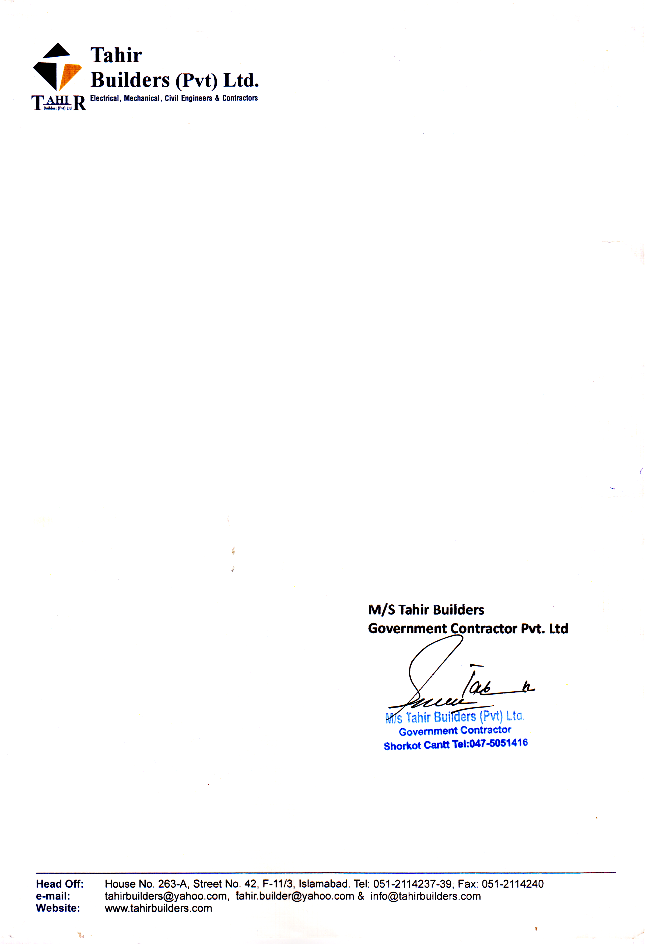

***TO WHOM IT MAY CONCERN***

This is to certify that Mr. <Name> S/O <fname> served in this organization as a <Designation> at PAF Base Shor Kot, from <From> to <To>.

During his stay with us he has shown full interest and commitment with his job. We wish him very success in his future life.